SCHOOL OF COMPUTER SCIENCE AND ARTIFICIAL INTELLIGENCE |  |  |  |  | DEPARTMENT OF COMPUTER SCIENCE ENGINEERING
Program Name: B. Tech |  |  |  | Assignment Type: Lab |  |  | Academic Year:2025-2026
Course Coordinator Name |  |  |  | Venkataramana Veeramsetty
Instructor(s) Name |  |  |  | Dr. V. Venkataramana (Co-ordinator)  Dr. T. Sampath Kumar  Dr. Pramoda Patro  Dr. Brij Kishor Tiwari  Dr.J.Ravichander  Dr. Mohammand Ali Shaik  Dr. Anirodh Kumar  Mr. S.Naresh Kumar  Dr. RAJESH VELPULA  Mr. Kundhan Kumar  Ms. Ch.Rajitha  Mr. M Prakash  Mr. B.Raju  Intern 1 (Dharma teja)  Intern 2 (Sai Prasad)  Intern 3 (Sowmya)  NS_2 ( Mounika)
Course Code |  |  | 24CS002PC215 | Course Title |  | AI Assisted Coding
Year/Sem |  |  | II/I | Regulation |  | R24
Date and Day  of Assignment |  |  | Week5 - Thursday | Time(s)
Duration |  |  | 2 Hours | Applicable to  Batches
AssignmentNumber:10.4(Present assignment number)/24(Total number of assignments)
 | Q.No. | Question |  |  |  |  |  | Expected Time  to complete
 | 1 | Lab 10 – Code Review and Quality: Using AI to Improve Code Quality and Readability  Lab Objectives  - Use AI for automated code review and quality enhancement.  - Identify and fix syntax, logical, performance, and security issues in Python code.  - Improve readability and maintainability through structured refactoring and comments.  - Apply prompt engineering for targeted improvements.  - Evaluate AI-generated suggestions against PEP 8 standards and software engineering best practices  Task 1: Syntax and Error Detection  Task: Identify and fix syntax, indentation, and variable errors in the given script.  # buggy_code_task1.py  def add_numbers(a, b)  result = a + b  return reslt  print(add_numbers(10 20))  Output:  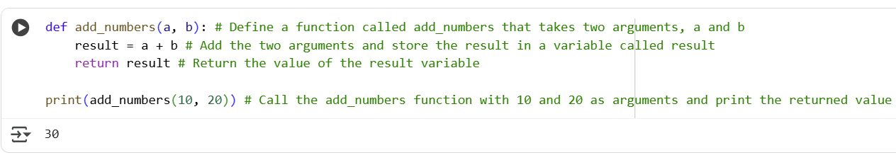  Explanation:  This code defines a simple function called add_numbers that takes two inputs, a and b. Inside the function, it adds these two numbers together and stores the sum in a variable named result. The function then returns the value of result. Finally, the code calls the add_numbers function with the values 10 and 20 and prints the returned sum, which is 30. The inline comments explain each step  Task 2: Logical and Performance Issue Review  Task: Optimize inefficient logic while keeping the result correct.  # buggy_code_task2.py  def find_duplicates(nums):  duplicates = []  for i in range(len(nums)):  for j in range(len(nums)):  if i != j and nums[i] == nums[j] and nums[i] not in duplicates:  duplicates.append(nums[i])  return duplicates  numbers = [1,2,3,2,4,5,1,6,1,2]  print(find_duplicates(numbers))  Output:  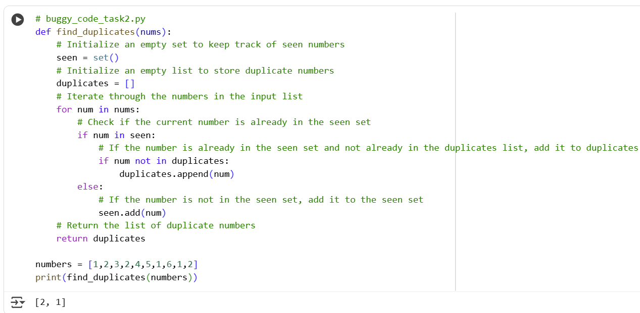  Explanation:  This Python code defines a function find_duplicates that efficiently finds duplicate numbers in a list. It uses a set called seen to keep track of numbers encountered so far and a list called duplicates to store the unique duplicates. It iterates through the input list nums. If a number is already in the seen set, it's a duplicate. The code adds it to the duplicates list only if it's not already there. If the number is not in seen, it's added to the seen set. Finally, the function returns the list of unique duplicates found.  Task 3: Code Refactoring for Readability  Task: Refactor messy code into clean, PEP 8–compliant, well-structured code.  # buggy_code_task3.py  def c(n):  x=1  for i in range(1,n+1):  x=x*i  return x  print(c(5))  Output:  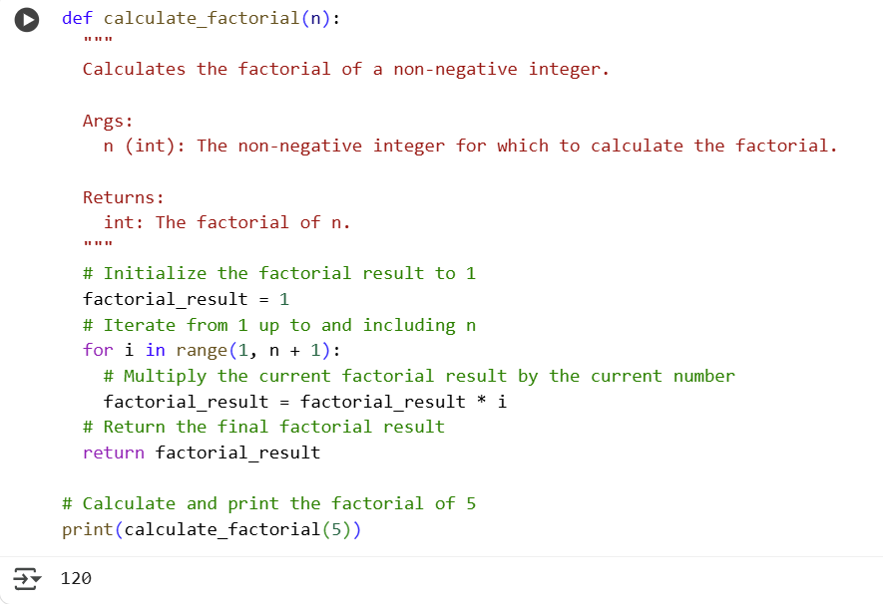  Explanation:  The primary difference lies in the structure and readability. The second code is better structured with a descriptive function name (calculate_factorial instead of c). It also follows standard Python indentation, making the code easier to read and understand. Additionally, the second version includes a docstring explaining the function's purpose and inline comments detailing each step, which were absent in the original code. These improvements make the code more maintainable and user-friendly  Task 4: Security and Error Handling Enhancement  Task: Add security practices and exception handling to the code.  # buggy_code_task4.py  import sqlite3  def get_user_data(user_id):  conn = sqlite3.connect("users.db")  cursor = conn.cursor()  query = f"SELECT * FROM users WHERE id = {user_id};" # Potential SQL injection risk  cursor.execute(query)  result = cursor.fetchall()  conn.close()  return result  user_input = input("Enter user ID: ")  print(get_user_data(user_input))  Output:  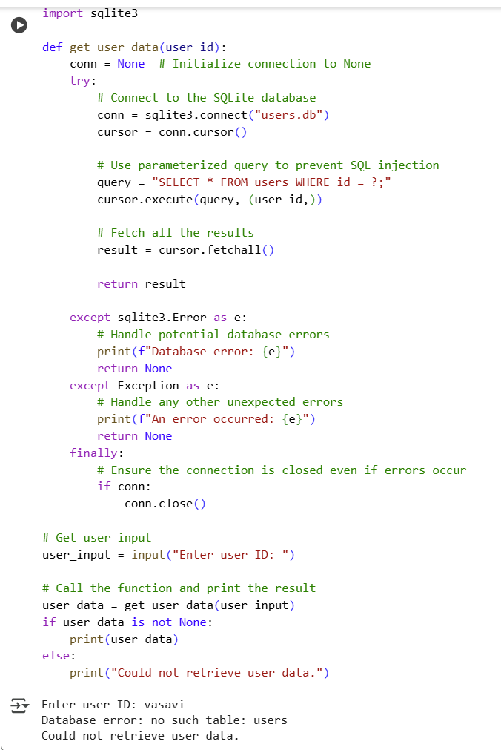  Explanation:  This code connects to an SQLite database named "users.db" to retrieve user data based on a provided user ID. It uses a try...except...finally block for robust error handling, specifically catching sqlite3.Error and general exceptions. The key security improvement is using a parameterized query (SELECT * FROM users WHERE id = ?; and passing (user_id,)) which prevents SQL injection by separating the SQL command from the user input. The finally block ensures the database connection is always closed, even if errors occur. If data retrieval is successful, it's printed; otherwise, an error message is displayed.  Task 5: Automated Code Review Report Generation  Task: Generate a review report for this messy code.  # buggy_code_task5.py  def calc(x,y,z):  if z=="add":  return x+y  elif z=="sub": return x-y  elif z=="mul":  return x*y  elif z=="div":  return x/y  else: print("wrong")  print(calc(10,5,"add"))  print(calc(10,0,"div"))  Output:  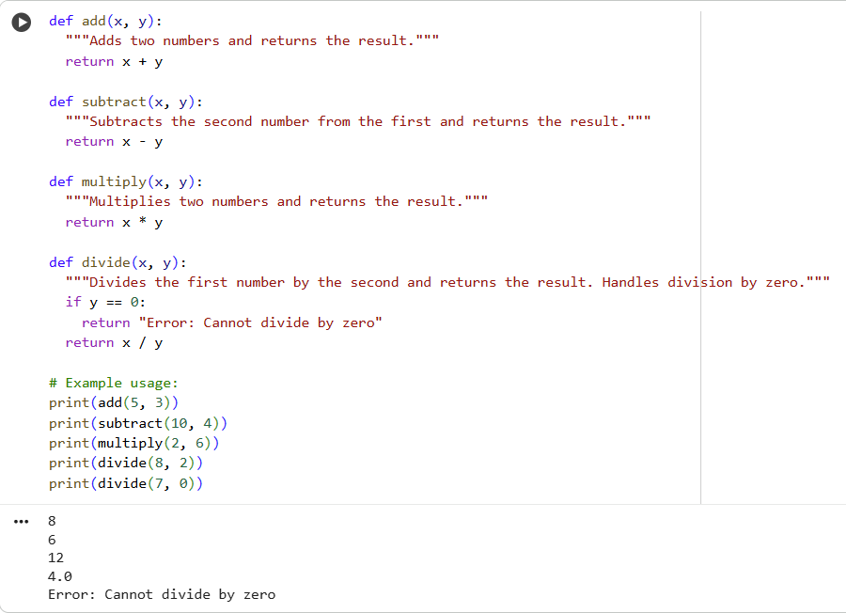 |  |  |  |  |  | Week5 - Thursday

